Name: William Huynh

Collaborators: Calista Nguyen, Amey Erdeneblieg

**Data Model**

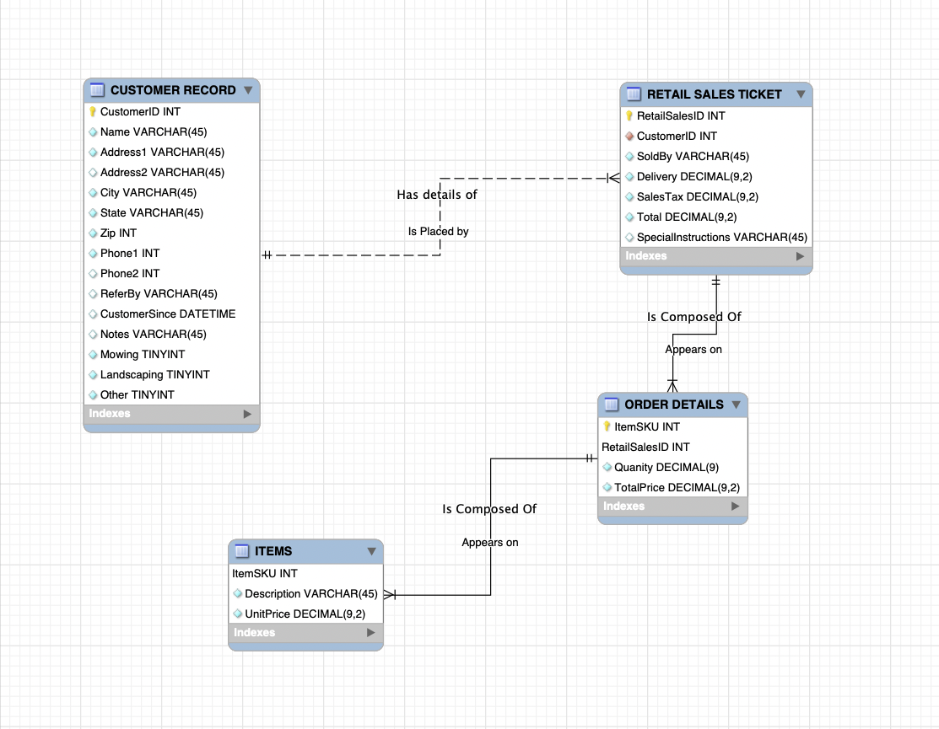

**DDL**

-- MySQL Script generated by MySQL Workbench

-- Sun Feb 14 18:27:49 2021

-- Model: New Model Version: 1.0

-- MySQL Workbench Forward Engineering

SET @OLD_UNIQUE_CHECKS=@@UNIQUE_CHECKS, UNIQUE_CHECKS=0;

SET @OLD_FOREIGN_KEY_CHECKS=@@FOREIGN_KEY_CHECKS, FOREIGN_KEY_CHECKS=0;

SET @OLD_SQL_MODE=@@SQL_MODE, SQL_MODE='ONLY_FULL_GROUP_BY,STRICT_TRANS_TABLES,NO_ZERO_IN_DATE,NO_ZERO_DATE,ERROR_FOR_DIVISION_BY_ZERO,NO_ENGINE_SUBSTITUTION';

-- -----------------------------------------------------

-- Schema mydb

-- -----------------------------------------------------

-- -----------------------------------------------------

-- Schema mydb

-- -----------------------------------------------------

CREATE SCHEMA IF NOT EXISTS `mydb` DEFAULT CHARACTER SET utf8 ;

USE `mydb` ;

-- -----------------------------------------------------

-- Table `mydb`.`CUSTOMER RECORD`

-- -----------------------------------------------------

DROP TABLE IF EXISTS `mydb`.`CUSTOMER RECORD` ;

CREATE TABLE IF NOT EXISTS `mydb`.`CUSTOMER RECORD` (

`CustomerID` INT NOT NULL AUTO_INCREMENT,

`Name` VARCHAR(45) NOT NULL,

`Address1` VARCHAR(45) NOT NULL,

`Address2` VARCHAR(45) NULL,

`City` VARCHAR(45) NOT NULL,

`State` VARCHAR(45) NOT NULL,

`Zip` INT NOT NULL,

`Phone1` INT NOT NULL,

`Phone2` INT NULL,

`ReferBy` VARCHAR(45) NULL,

`CustomerSince` DATETIME NULL,

`Notes` VARCHAR(45) NULL,

`Mowing` TINYINT NOT NULL,

`Landscaping` TINYINT NOT NULL,

`Other` TINYINT NOT NULL,

PRIMARY KEY (`CustomerID`))

ENGINE = InnoDB;

-- -----------------------------------------------------

-- Table `mydb`.`RETAIL SALES TICKET`

-- -----------------------------------------------------

DROP TABLE IF EXISTS `mydb`.`RETAIL SALES TICKET` ;

CREATE TABLE IF NOT EXISTS `mydb`.`RETAIL SALES TICKET` (

`RetailSalesID` INT NOT NULL AUTO_INCREMENT,

`CustomerID` INT NOT NULL,

`SoldBy` VARCHAR(45) NOT NULL,

`Delivery` DECIMAL(9,2) NOT NULL,

`SalesTax` DECIMAL(9,2) NOT NULL,

`Total` DECIMAL(9,2) NOT NULL,

`SpecialInstructions` VARCHAR(45) NULL,

PRIMARY KEY (`RetailSalesID`),

CONSTRAINT `fk_RETAIL SALES TICKET_CUSTOMER RECORD`

FOREIGN KEY (`CustomerID`)

REFERENCES `mydb`.`CUSTOMER RECORD` (`CustomerID`)

ON DELETE NO ACTION

ON UPDATE NO ACTION)

ENGINE = InnoDB;

CREATE INDEX `fk_RETAIL SALES TICKET_CUSTOMER RECORD_idx` ON `mydb`.`RETAIL SALES TICKET` (`CustomerID` ASC) VISIBLE;

-- -----------------------------------------------------

-- Table `mydb`.`ORDER DETAILS`

-- -----------------------------------------------------

DROP TABLE IF EXISTS `mydb`.`ORDER DETAILS` ;

CREATE TABLE IF NOT EXISTS `mydb`.`ORDER DETAILS` (

`ItemSKU` INT NOT NULL,

`RetailSalesID` INT NOT NULL,

`Quanity` DECIMAL(9) NULL,

`TotalPrice` DECIMAL(9,2) NULL,

`RETAIL SALES TICKET_RetailSalesID` INT NOT NULL,

PRIMARY KEY (`ItemSKU`, `RetailSalesID`, `RETAIL SALES TICKET_RetailSalesID`),

CONSTRAINT `fk_ORDER DETAILS_RETAIL SALES TICKET1`

FOREIGN KEY (`RetailSalesID`)

REFERENCES `mydb`.`RETAIL SALES TICKET` (`RetailSalesID`)

ON DELETE NO ACTION

ON UPDATE NO ACTION)

ENGINE = InnoDB;

CREATE INDEX `fk_ORDER DETAILS_RETAIL SALES TICKET1_idx` ON `mydb`.`ORDER DETAILS` (`RetailSalesID` ASC) VISIBLE;

-- -----------------------------------------------------

-- Table `mydb`.`ITEMS`

-- -----------------------------------------------------

DROP TABLE IF EXISTS `mydb`.`ITEMS` ;

CREATE TABLE IF NOT EXISTS `mydb`.`ITEMS` (

`ItemSKU` INT NOT NULL AUTO_INCREMENT,

`Description` VARCHAR(45) NOT NULL,

`UnitPrice` DECIMAL(9,2) NOT NULL,

PRIMARY KEY (`ItemSKU`),

CONSTRAINT `fk_ITEMS_ORDER DETAILS1`

FOREIGN KEY (`ItemSKU`)

REFERENCES `mydb`.`ORDER DETAILS` (`ItemSKU`)

ON DELETE NO ACTION

ON UPDATE NO ACTION)

ENGINE = InnoDB;

SET SQL_MODE=@OLD_SQL_MODE;

SET FOREIGN_KEY_CHECKS=@OLD_FOREIGN_KEY_CHECKS;

SET UNIQUE_CHECKS=@OLD_UNIQUE_CHECKS;

**Assumptions**

My list of Surrogate Keys:

1. **CustomerID**, this key was made to uniquely identify the customer. This is because there was no other option that could uniquely identify the customer.It is also auto-incremented.
2. **RetailSalesID**, this key was made to uniquely identify the retail sale. This is because there was no other option that could uniquely identify the customer. It is also auto-incremented.

Other notes:

1. Under the **ORDER DETAILS** table, there is a composite key that consists of ItemSKU and RetailSalesID. RetailSalesID does not have a key symbol in front of it, my assumption is that MySQL got buggy and therefore I am not able to obtain the key symbol.
2. Under the **ITEMS** table, ItemsSKU should have a key symbol in front, MySQLworkbench got rid of it for some reason and I cannot get that symbol to appear again.